Year 10 Science (General)
Semester 1 Examination 2020 - Revision

Astronomy

1. Complete the following table.

TERM | DEFINITION
light year
constellation
galaxy
nebula
supernova
red giant
black hole
sunspot
corona
fusion

2. Light travels at 300,000 km/sec. A star is 97.6 light years away. We can only travel at about 15 - 20 km/second with our best rockets.

(a) With our current technology, are we likely to be able to travel to this star in the near future? Give a few reasons for your answer.

YES / NO (Circle your answer.)

Reasons: •

•

•

(b) Suggest one way we might be able to overcome the time factor of travelling to other galaxies, given it could be hundreds of years.

3. (a) What is the major element found in the Sun?

(b) What happens to this element so that the Sun produces its energy?

(c) The Sun loses 5 million tonnes of mass per second. According to Einstein's equation (E = mc²), what does this mass become?

4. How is the surface temperature of a star related to its colour?

TEMPERATURE | COLOUR
 | blue
 | red
 | yellow

5. (a) About how old is our Sun (in millions of years)? million years

(b) How much longer will it "live"? million years

6. (a) Draw a flow diagram (with arrows) to show the stages of our Sun's remaining life as it runs out of fuel.

Sun

(b) Do similar flow diagrams for the following types of stars.

Huge star

Giant star

(c) The difference between a nova and a supernova is the size of the explosion that takes place. What happens to a star to cause it to explode?

7. (a) Describe the size of the gravity near a black hole.

(b) Why does a black hole appear black?

8. Complete the following matrix to compare the Big Bang and Steady State Theories, using ticks to show which statements apply to one, both or neither theory.

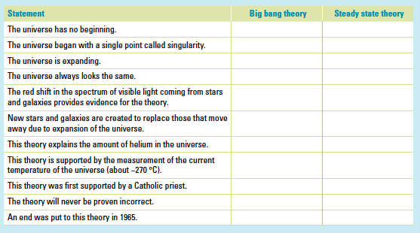

9. Why are the constellations we see now so different from the way they were many centuries ago?

10. How have scientists gained their knowledge of the life and death of stars if the processes involved take millions of years to occur?

11. What is the difference between a neutron star and a black hole?

12. What makes stars group together to form galaxies?

13. The Doppler effect is most commonly associated with the changing pitch of a sound as its source moves past you. For example, the pitch of the noise made by a speeding train increases as it approaches you and decreases as it moves away from you. Explain how the Doppler effect is relevant to the study of the universe.

14. What is cosmic microwave background radiation and why does it exist?

15. Below is a list of the four spheres on Earth. Give a brief description of each.

Biosphere:

Atmosphere:

Hydrosphere:

Lithosphere:

16. (a) What is the ozone layer and why is it important for Earth?

(b) How has humankind damaged this layer?

17. What is the difference between weather and climate?

18. Describe two consequences of global warming.

•

•

19. The following diagram shows the rock cycle and the water cycle. Complete the diagram with appropriate labels.

20. (a) Label the diagram below showing the water cycle.

(b) Describe how water entering the roots of the tree ends up in the lake or river shown.

21. The following diagram shows the carbon cycle.

(a) Label the processes missing from the diagram.

(b) Describe how the carbon in the fossil is recycled to end up in the tissues and systems of the cow.

22. Use the diagram of the nitrogen cycle to answer the following questions.

(a) Explain how nitrogen gas (N₂) in the atmosphere is converted into ammonium (NH₄¹⁺).

(b) Plants needs nitrates (NO₃¹⁻) to grow. How does NH₄¹⁺ become NO₃¹⁻?

(c) What is the role of the decomposers in the cycle?

23. The phosphorus cycle is shown in the following diagram.

(a) How does the phosphate in the rock become phosphate in the soil for plants to use?

(b) How does phosphorus get from the soil into an animal's systems?

(c) What is the role of marine plants and animals in recycling phosphorus?

Human Biology

1. (a) What are the male and female gametes in animals called?

(b) What are the genotypes for a male and a female?

2. DNA is thought to be a twisted ladder structure called a double helix. There are a series of bases located between the two strands of the helix.

(a) Name the four bases.

(b) Which bases are paired together?

(c) What are the bases made of?

3. Define the following terms.

allele
pure-bred
hybrid
homozygous
heterozygous
genotype
phenotype
sex-linked
dominant
recessive
co-dominant
incomplete dominance
haploid
gene

4. Below is a diagram showing a cell division process.
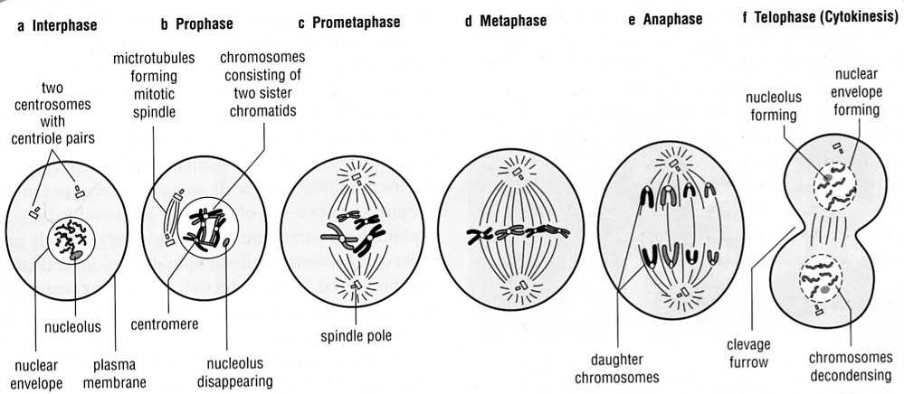
(a) Is this meiosis or mitosis?

(b) Describe what is happening at each stage to the chromosomes.

(c) If possible, name each stage.

(d) In which cells does this process occur?

5. (a) Why do cells undergo mitosis?

(b) Why do cells undergo meiosis?

(c) In what way do the cells produced by these two processes differ?

6. Polled cattle do not have horns. This is a dominant phenotype arising from the action of an autosomal gene P. Horned cattle are therefore pp homozygotes.

(a) If a polled bull and a polled cow have a horned calf, what are the genotypes of the parents?

(b) If the same bull was bred with many horned cows, what would the proportions of polled and horned offspring overall be? Show full working.

7. In Andalusian chickens, the black characteristic is incompletely dominant to the white-splashed characteristic. The heterozygous (hybrid) condition produces blue chickens.

(a) How is incomplete dominance different to co-dominance?

(b) Determine the genotype and phenotype of the F1 generation from a pure-bred black Andalusian crossed with a blue Andalusian.

8. The following pedigree shows the occurrence of no ear lobes in a family.

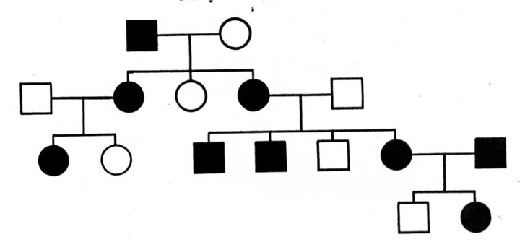

(a) Is the characteristic dominant or recessive (according to the pedigree)?

(b) Explain why you made that determination.

(c) Determine the genotype of every individual in the pedigree. (Remember to start from the bottom!)

(d) How many females have no ear lobes?

9. (a) How many chromosomes are found in a human skin cell?

(b) How many chromosomes are found in the reproductive cells?

(c) Name the process used to make reproductive cells?

10. (a) What is the difference between the male and female sex chromosome pair?

(b) Who determines the sex of a child - the mother or father? Explain.

(c) Show, by punnet square, why half of any particular population would be expected to be female.

(d) A family has had five boys born into it, and the mother is pregnant with the sixth child. What is the chance that the child will be a girl? Explain why.

